Daily Maths Programme From MathsQUBe

The Maths Academy at Queen University Belfast is working to deliver MathsQUBe, a FREE programme of daily maths activities for primary school children.

To learn all about the programme and to subscribe to the channel please click on the link below.

http://www.qub.ac.uk/about/Leadership-and-structure/Faculties-and-Schools/Engineering-and-Physical-Sciences/mathsacademy/mash/MathsQUBe/

QUB are hoping to have the first video launched on the 6th of April so remember to tune in everyday at 10.30am as QUB will bring a new fun maths educational video which teaches children the importance of maths in our everyday lives and shows how important maths is for so many things. Maths is hidden everywhere.

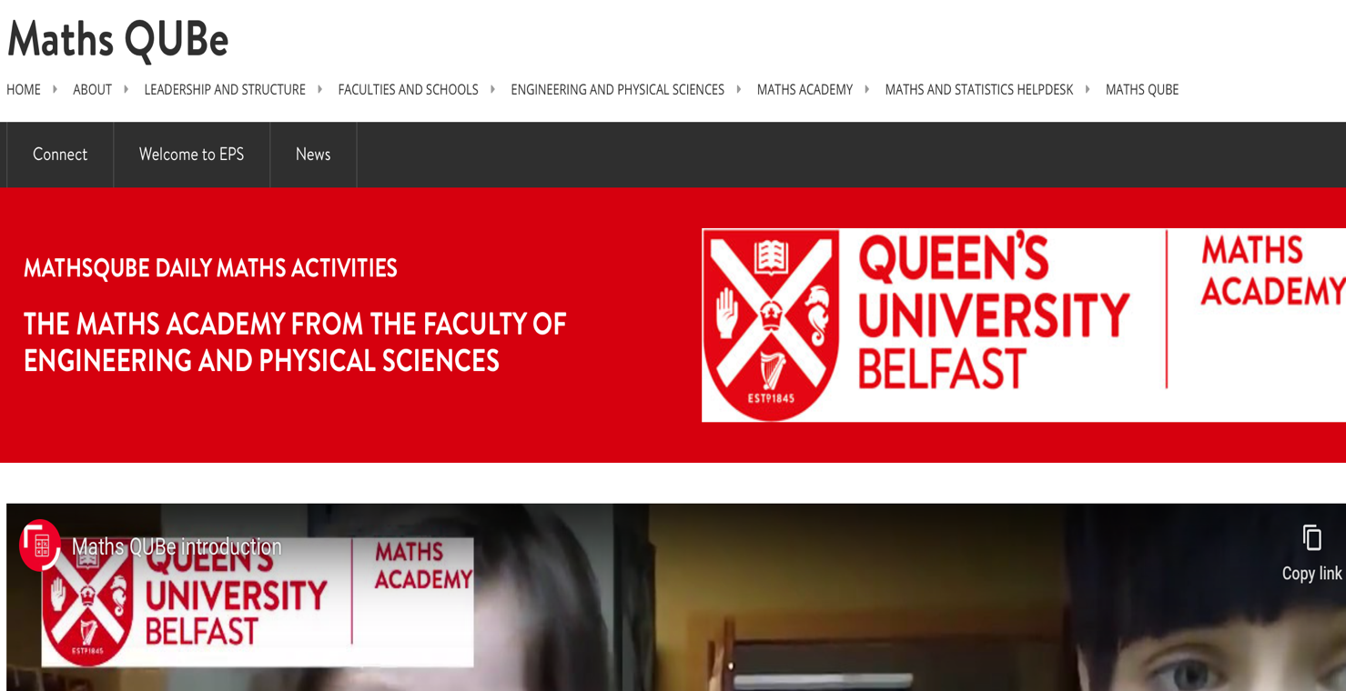

Calling all children, parents, cats, dogs etc to help create fun and creative maths videos of maths all around us!!!

I am also looking for parents and children to make a short 2/3 minute video on something related to maths in your life.

It can be as simple as a song set to the multiplication tables multiplication or
maybe when you are doing your fitness or Tik Tok videos (in your spare time!) you can use angles to explain the correct way to exercise. You might use fractions to measure food in a recipe or while cutting and sharing your favourite pizza!! If you are really creative you could show how taking precise measurements or estimating the cost and profit of materials is essential. Or you could look for shapes and symmetry in things inside and outside your house.

Don’t forget to tell us a bit about yourself (class, age, teacher) at the start and why you like maths. Then do your maths thing and if possible, include an activity for other children to try to do!

If you have a fun maths activity you would like to create and share please send to either myself, aquinn276@c2kni.net or Mrs McAuley cmauley911@c2kni.net
We welcome videos from EVERYBODY - (Nursery to Year 7) and include your pets and other family members if you can get them to cooperate. Thankyou so much in advance – I can’t wait to see what you are all getting up to.

Be imaginative - maths is everywhere!

