May Maths Challenge
Year 5
Fraction Riddles
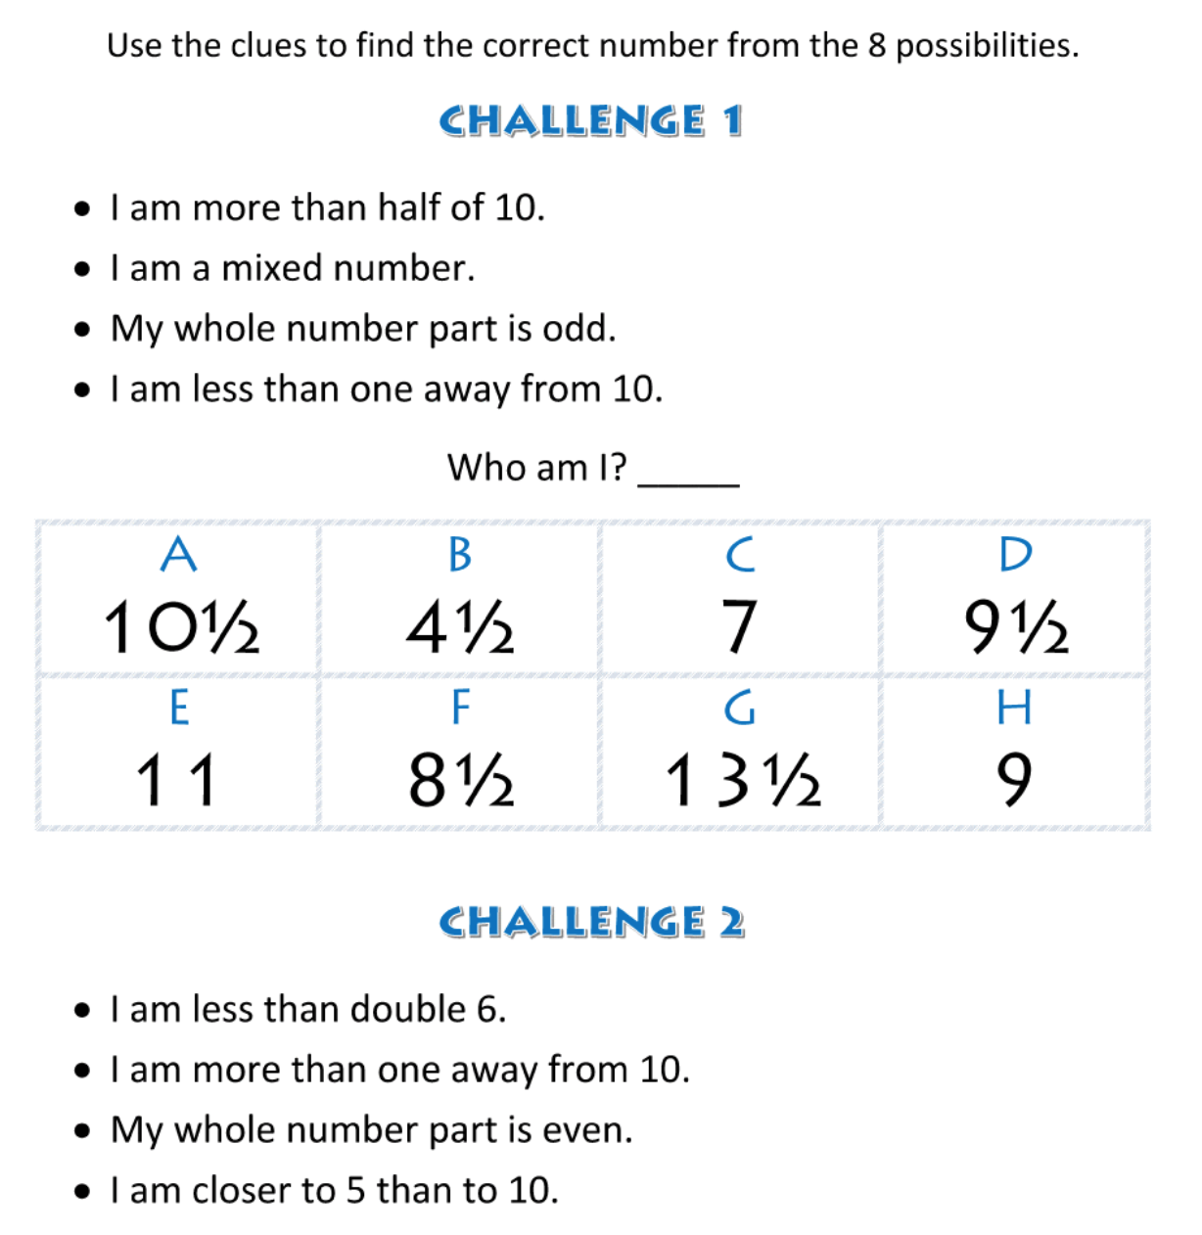
Who am I? ______

Good Luck Children!
(I will post the answers at the end of the month.)
Extra Brain Teaser For All The Family
