May Maths Challenge
Year 6 and 7
Magic Squares Challenge
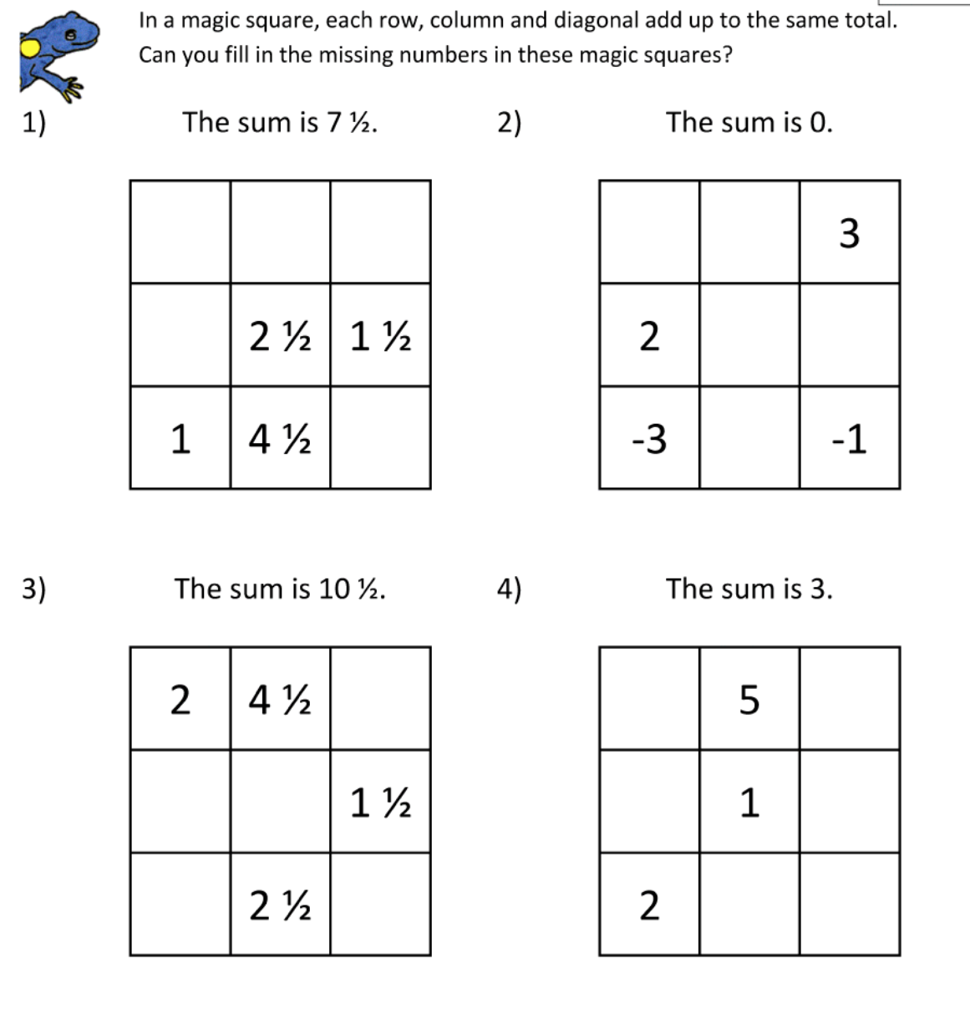

Good Luck Children!
(I will post the answers at the end of the month.)

Extra Brain Teaser For All The Family

