
St. Mary's P.S.
May/June Newsletter
Year 3

It’s hard to believe we’re in the final term of Year 3. During May and June our topic will be ‘Famous People’. Children will look at the lives of Florence Nightingale, Louis Braille, Anne Frank, Columbus and Samuel Pepys.

Other planned activities are as follows:

• Talking about May being the month of Mary, the Mother of God. We will discuss the mysteries of the Rosary, Rosary beads and the important events in Mary’s life.

• Children will complete class tests in the week beginning 16th May.

• Year 3 Sports Day to be held in the school on Tuesday 31st May at 1pm.

Literacy

Planned literacy activities include,
- using dictionaries to locate words for spelling and meaning.
- using flow diagrams to explain how something happens for
e.g. lifecycles of frog/butterfly.
- revising use of punctuation effectively.
- continue with fiction/non-fiction readers.
- extracting information from digital sources (BBC Histories DVD)
- exploring short stories that have morals (Aesop’s Fables).
- Linguistic Phonics activities – oa,ow,o-e/er,ir,or,ur/ee,ea words.

Numeracy

We will be looking at:
- Time – o’clock, half past, quarter past and quarter to.
- the sequence of days of the week, months of the year and the seasons.
- Fractions, namely ½ and ¼.
- Count in multiples of 2, 5 and 10 (which is in preparation for times tables in Year 4).
- Continue number bonds and carry out simple investigations.
- Continue to use Alta Maths.

We are using an excellent website ‘Topmarks’ in class also. It has lots of useful Literacy/Numeracy activities your child may enjoy.

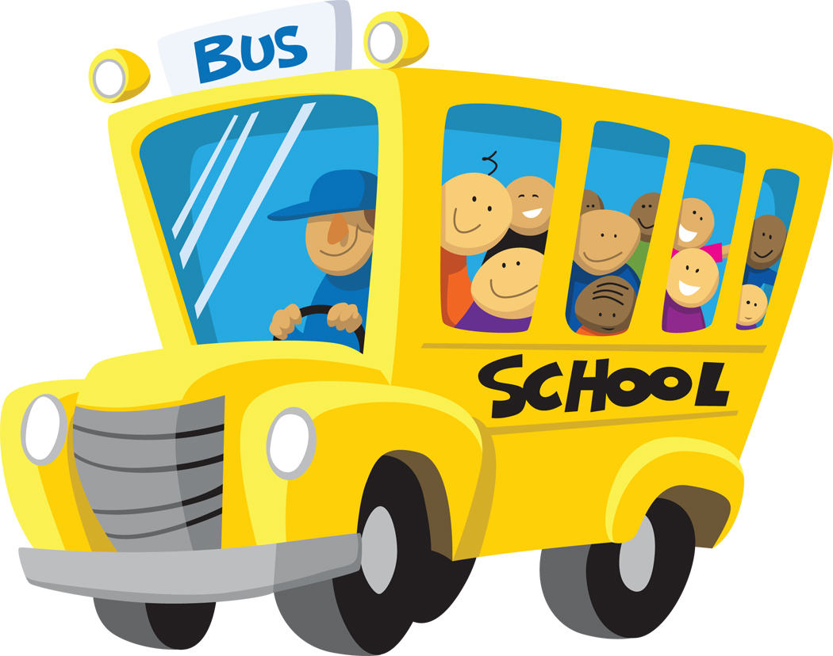
School Trip
We plan to have a school trip in June for our Year 3
classes. Details later.

As always we want to thank you for your continued
support.


Mrs Devenney Mrs Loughran

